Proposal for a Neighbourhood Improvement Scheme under the Housing Act 2004 regarding three areas of the borough suffering from persistent and significant anti-social behaviour and deprivation.
Table of Contents

1 | Introduction |  | 2
2 | Legislative Framework |  | 3
3 | The Proposal |  | 7
 | 3.1 | South Harrow Area | 8
 | 3.2 | The Wealdstone High Street Area | 21
 | 3.3 | The Edgware Area | 30
4 | Housing Demand |  | 36
5 | Conclusion |  | 48
6 | How will the Neighbourhood Improvement Scheme tackle anti-social behaviour? |  | 50
7 | Options Appraisal |  | 51

Section 2 – Report

1. Introduction

Local authorities can decide to designate a selective licensing scheme either because they have areas of low housing demand and/or are experiencing “a significant and persistent” problem of anti social behaviour in an area. The former does not apply to Harrow as house prices have risen all over but the latter does in some areas.

While Harrow’s crime rates are among of the lowest of London boroughs, this report draws attention to the following three areas of the borough South Harrow, Wealdstone High Street and north-east Edgware reported in the Harrow Strategic Assessment 2012 as consistent hotspots for crime and anti-social behaviour (ASB).

This report provides evidence that these areas are particularly affected by crime and ASB compounded by deprivation and that there is connection to the private rented sector. The council recognises that the private rented sector offers housing for many people in the borough and it is not the aim of this proposal to make this market impeded for tenants or landlords. For years the areas highlighted in this report have been beset by crime, anti-social behaviour and poor housing standards that the residents and visitors who live and work here have had to endure. This has no doubt contributed to the decline of the area and the negative influx of residents. The council believes these problems can be tackled more effectively if poor landlords showed more interest in running their properties professionally and diligently.

It is proposed that Harrow Council designate the areas outlined in green in figures on Map 1, 2 and 3 below as the selective licensing areas, with the area in green being the wider consultation area. The three maps set out the boundaries of the proposed areas which for the purpose of this report shall be titled the South Harrow Area, the Wealdstone High Street Area and the Edgware Area.
The way in which these properties are used has led to substantial problems in the area which are detailed in this report. Should the designation be made it will last for 5 years and is intended to reduce ASB and deal with the poor management of privately rented accommodation in a combined approach with other initiatives and strategies.

The Council wishes to work alongside private landlords who often provide much needed housing for the people of Harrow, but are not ready to accept landlords who fail to show interest in operating responsibly or tenants who are a nuisance to others.

The selective licensing scheme’s goal is to produce landlords in the proposed designated areas who will be committed, responsible, and cooperative and involved in the smooth running of their rented properties. This will contribute in the long-term to better homes, an area worth investing in and a positive effect on the quality of life for the local community.

The successful selective licensing schemes in Blackburn with Darwen, Newham, Middlesbrough and elsewhere demonstrate that this legislative tool is effective and curtails the negative activity of absentee and unscrupulous landlords who are free to roam under the radar thereby undermining the local area.

2. Legislative framework
Housing Act 2004 – Types of Discretionary licensing

Under parts 2 and 3 of the Housing Act 2004 (the Act) Local Authorities have the power to introduce a discretionary licensing scheme.

There are two types of scheme that can be considered; Additional licensing which Harrow Council already has in place and Selective licensing.

Selective licensing is a regulatory tool provided by Section 80 of the Act. This section states that a selective licensing scheme can be declared if one of two general conditions is met. The first relates to low housing demand which is not an issue in Harrow, but the DCLG Guidance (March 2015) also allows it for an area must have one or more of the following being experienced:

    - significant and persistent problem caused by anti-social behaviour (ASB),
    - poor property conditions,
    - high levels of migration,
    - high level of deprivation
    - high levels of crime

The Communities and Local Government (CLG) Approval steps for additional and selective licensing designations in England guidance says that an area can be deemed to be suffering from significant and persistent anti-social behaviour if it suffers from:
- Crime: tenants not respecting the property in which they live and engaging in vandalism, criminal damage, burglary, robbery/theft and car crime.
- Nuisance Neighbours: intimidation and harassment; noise, rowdy and nuisance behaviour; animal related problems; vehicle related nuisance. Tenants engaged in begging; anti-social drinking; street prostitution and kerb-crawling; street drugs market within the curtilage of the property.
- Environmental Crime: tenants engaged in graffiti and fly-posting; fly-tipping; litter and waste; nuisance vehicles; drugs paraphernalia; fireworks misuse in and around the curtilage for their property.
Section 80 (6) (b) of the Act requires local authorities to consider that:
- Some or all of the private sector landlords who have let premises in the area are failing to take action to combat such problems that it would be appropriate for them to take.
- A landlord has responsibility to ensure persons he has permitted to reside at a property do not cause an annoyance or nuisance to other persons residing in it, or other persons living, working or visiting the immediate neighbourhood. If anti-social behaviour is being carried out within the immediate vicinity of the property and is being caused by the occupiers of it, then it would be reasonable to expect a landlord to ensure that those persons are not conducting themselves in a way that is adversely impacting on the local community. This applies equally to visitors to the property.’ (Approval steps for additional and selective licensing designations in England, CLG)

The Guidance is clear on the information the local authority is required to provide. Section 4 details the proposal for a selective licensing scheme in Blackpool and the evidence that this type of scheme is needed.

The March 2015 guidance is consistent in this approach.

Properties covered by selective licensing

By making the designation, all privately rented accommodation in the designated area will require a licence. Owners of rented properties will be required to make an application to the Council for a licence and will need to nominate either the manager or the owner to be the licence holder.

Section 79(2) details those houses that are covered and this is defined as a whole house that is occupied either under:
a) A single tenancy or licence
b) Under two or more tenancies or licences in respect of different dwellings contained in it.
This definition has been interpreted to mean the following:
a) A house let under a single tenancy only requires one licence.
b) Where the freeholder of a building containing a number of flats, owns all the flats and lets those flats on tenancies or licences (not including long leasehold), then the freeholder will be required to apply for one licence to cover the whole building containing the flats.
c) A building containing flats where each flat is owned by a long leaseholder and the flats are individually rented out, the leaseholder will be required to apply for a licence for their individual flat.
d) A building containing flats where there is a mixture of different long leaseholders and accommodation owned by the freeholder, each of the leaseholders would require an individual licence for their flat or flats and the remaining accommodation would require a licence applied for by the freeholder.
e) Landlords who own more than one ‘house’ under the above definitions within the designated area will need to apply for a licence for each of those houses.
f) Houses being used as houses in multiple occupation and are not covered by the Mandatory licensing scheme, will need a licence and the owner or manager will be required to apply.

Licence Applications and Fees

Section 87 of the Act details the application process for a licence. In particular this section states that an application must be made in accordance with such requirement as specified by the authority. It also states that the authority may require the application to be accompanied by a fee fixed by the authority.

When fixing fees under this section of the Act the local authority may take into account all costs incurred to carry out their functions under this part of the law.

The application process is detailed within the Act and there are subsequent regulations detailing the contents of an application form. This includes providing information on the property layout, certificates for gas, furniture and fire safety. The Licensing and management of Houses in Multiple Occupation and Other Houses (Miscellaneous Provisions) (England) Regulations 2006 schedule 2 provides full details on what must be included within an application this includes determining if the manager or proposed licence holder is a fit and proper person.

Conditions and penalties

Once an application has been made the local authority must consider whether to grant or refuse the licence and the licence holder must firstly pass the Fit and Proper Person Test as defined by the Housing Act 2004 (section 66 (2)). This test specifies that the local authority must take into account evidence of any of the conduct detailed below and also applies to anyone “associated or formerly associated with the proposed licence holder or manager “whether on a personal, work or other basis”, if relevant. The matters that the local authority needs to have a regard to are:
- Any offence involving fraud, or other dishonesty, or violence or drugs in section 3 of the Sex Offences Act 2003
- Practiced unlawful discrimination of the law in connection with the carrying out of any business
- Contravened any provision of the law relating to housing or landlord and tenant law – illegal eviction etc
- Acted other than in accordance with any code of practice for the management of HMOs

N.B. Any “spent” convictions cannot be taken into account. However a lack of conviction may not mean that the incident was not relevant. The manager must send in with their application proof of their status and that they do not have any unspent convictions as specified above.

In the event that the landlord would not pass the fit and proper person test then he/she can nominate a manager in their place who must pass this test. If the local authority is not satisfied then it must refuse the application and give its reasons for this. The local authority must grant a licence if it is satisfied that:
- The property is reasonably suitable
- The licence holder would be a fit and proper person
If the licence is granted it will have conditions attached to it. Section 90 and Schedule 4 of the Act details the mandatory licence conditions that must be included, however there is provision for the local authority to add additional conditions that are either specific to the licence in question or that are locally agreed to address specific issues.

A licence would be valid for 5 years; however, the local authority has the discretion to grant the licence for a shorter period of time where there are problems with the application such as evidence of insufficient management.

Once the licence has been issued the licence holder must comply with the conditions attached to the licence. Where there is a breach of those conditions the licence holder may be prosecuted with a fine of up to £5,000 per breach.

If the licence application is refused the local authority must instigate an interim management order. This is where the local authority takes over the management of the property for up to one year or until such time as the owner is able to rectify the reasons for the licence being refused. If the owner is unable to rectify the problems then the local authority can apply for a Final management order where they take on the management for up to 5 years.

In some circumstances rather than refuse the licence it may be possible for the owner to apply for a temporary exemption notice under section 86 of the Act. This allows 3 months for the owner to take such steps as are necessary so the property no longer requires a licence.

Where a property requires a licence but the owner has not applied for one the owner can be prosecuted. Failing to apply for a licence could lead to prosecution and a fine of up to £20,000.

In addition to the fine there is a provision under section 96 of the Act for a Rent Repayment Order. This allows amounts paid in respect of a house or other periodical payment payable in connection with a tenancy or licence to be recovered for the period that the property should have been licensed.

Under section 98 of the Act there is also a restriction on terminating tenancies where a property is not licensed. This section states that ‘No section 21 notice may be given in relation to a short hold tenancy of the whole or part of an unlicensed house so long as it remains a house’.

The Current situation

3. The proposal
The designation will be used to tackle anti-social behaviour (ASB) in the area and to assist in improving the quality and the management of rented accommodation. Every privately rented flat, house or room (unless already licensed as a HMO under the existing mandatory scheme) will require a licence to operate in the area and landlords will be responsible for making an application to the Council.

The council aims to achieve the following outcomes:

- To improve how the private rented stock is being managed in the proposed areas for designation.

- To promote sustainable communities by cutting down on the high population turnover.

- To reduce the incidence of anti-social through educating landlords and tenants, implementing conditions, enforcement and advice and support

- To encourage landlord accreditation

The Government Guidance on setting a selective licensing designation; describes the conditions as being:
“The area is experiencing a “significant and persistent” problem caused by anti-social behaviour and that some or all private landlords in the area are not taking appropriate action to combat the problem that it would be appropriate for them to take; and that the making of the designation, when combined with other measures taken by the LHA (Local Housing Authority), or by the LHA in conjunction with others, will lead to a reduction in, or elimination of the problem.”

The evidence to justify fulfilling this criterion has been procured from several sources listed below:

- The 2011-2012 Harrow Strategic Assessment by Harrow council
- The Census 2011
- Harrow council Environmental Health database of service requests
- Metropolitan Police Crime Reporting Information System (CRIS) which lists all police call outs
- Fire Authority

The three areas have been preliminarily labelled as the following: the South Harrow Area, the Wealdstone High Street Area and the Burnt Oak Broadway Area. The council wards in which the designated areas are located will be examined to provide a clear picture of the problems in these areas.

NB: With the exception of borough boundaries, all boundary lines for the designated areas running parallel through a road shall include properties on both sides of that road and shall include the rear garden where applicable.

3.1 The South Harrow Area

The South Harrow Area proposed for designation bordered in green below under this scheme encompasses the eastern parts of both Roxbourne and Roxeth wards:

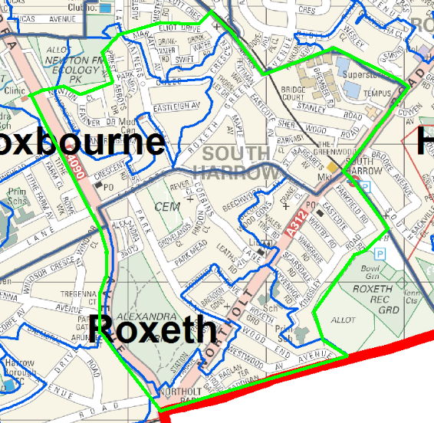

Fig. 1
Crime and Anti-Social Behaviour
The proposed area straddles the following wards: Roxbourne, Roxeth and a corner of Harrow on the Hill.

Crime and anti social behaviour are a concern within the proposed area and form the major reason for the proposal.

The area suffers from a number of fires both deliberate and accidental each year. The Fire Service attended a total of 1,575 deliberate fires in Harrow during 2012-2013, of which 110 (7%) were in the Roxbourne and 53 (3.4%) in Roxeth in which the South Harrow Area is situated. Although the ward boundaries are obviously a greater area than the designated project area they give an indicator as to the problems experienced in South Harrow.

Crime is a significant factor in parts of the borough with Roxeth and Roxbourne having the third and fourth highest confirmed reports of serious violent crimes respectively for the 2012-2013 financial year.

For serious violent offences, Roxbourne consistently is among the wards with above average rates rising 11.6 % between the years 2009/10 to 2010/11.

Aside from the Harrow Town Centre in Greenhill with its expected attraction for criminal elements to congregate around the licensed late night entertainment premises, pubs and transport hub, the South Harrow area was named in the 2011-2012 Harrow Strategic Assessment as one of three chief hotspots for crime and anti-social behaviour in Harrow.

Figures 1, 2 and 3 depict all recorded crime in a 1km radius of South Harrow between 2008-2011. There is a high degree of continuity over the three year period in terms of the location of hotspots, with a strip along Northolt Road around South Harrow Station. The location of South Harrow within relatively small parts of three wards: Roxeth, Roxbourne and Harrow on the Hill, can make it more difficult to identify problems and coordinate interventions for police. This is why this location would be ideal for the Neighbourhood Improvement Scheme as the designated zone can cross borders to cover the problem areas highlighted in the Harrow Strategic Assessment report and therefore planning and strategy can be focused more effectively into the area with the most concern allowing better coordination between local authority and police to tackle the problems therein.

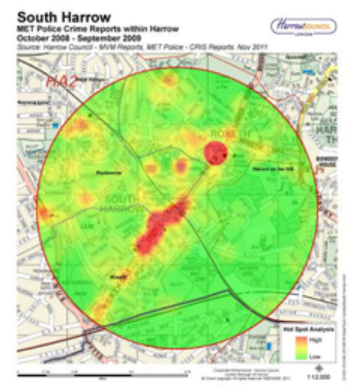Fig.2 covering incidents 2008-2009
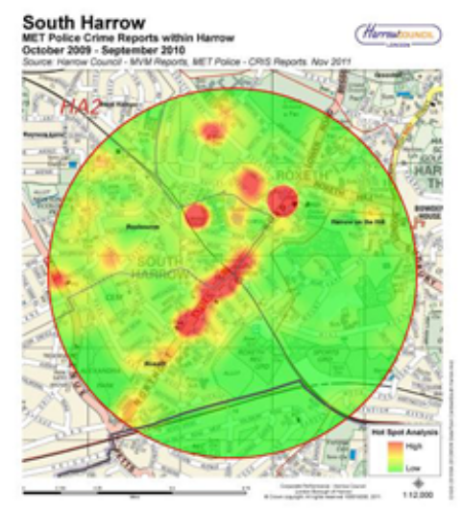 Fig.3 covering incidents 2009-2010
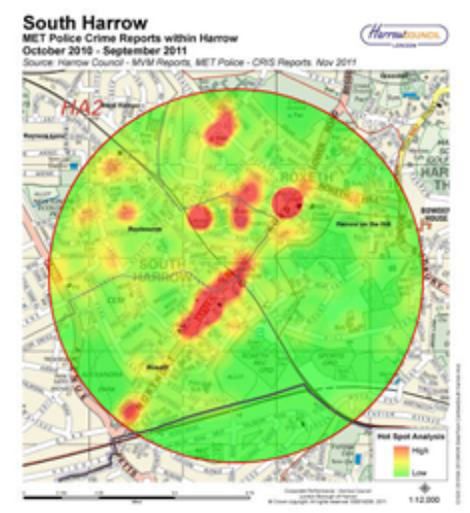Fig.4 covering incidents 2010-2011

Criminality and ASB are closely related and often high areas of crime are riddled with ASB. The Audit Commission report published in 2006 (Community Safety national Report May 2006) stated that ‘fear of crime and concern about anti-social behaviour reduce the quality of life in the area where people live’ so, the level of crime provides a wider picture of the proposed area for designation and highlights the issues that residents in the area are faced with.

ASB Reports Received by the Police

ASB figures in Harrow show a seasonal trend with more incidents occurring in summer than in winter. The most recent data for 2012-2013 show that the main forms of ASB reported to the police are harassment and threats to kill, fear/provocation of violence and abusive, disorderly behaviour.

The figure below depicts the volume of ASB reports per ward in the last financial year and shows that Roxbourne ward is among the higher wards.

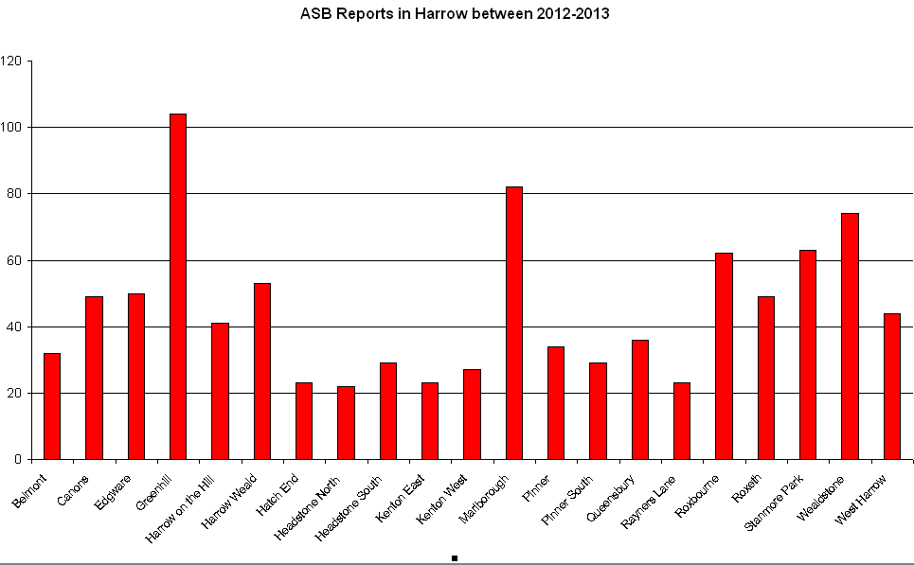
Fig. 5

The overall rate per 1000 of ASB reports have declined in recent years but Roxbourne ward has had a higher than average rate of police call outs for ASB than Harrow on the whole and this trend has been consistent for the last four years at least. For the year 2012-2013 the average rate of ASB call outs was 4.1 compared to Roxbourne ward’s rate of 4.6. While other wards may have experienced higher rates of ASB, when the data is mapped, it illustrates that not all of Roxbourne or Roxeth are affected (see below). The clustering is more concentrated in the Northolt Area, which has been consistent for the last several years.

The figures below show the hot spots of ASB in the borough over the last four years 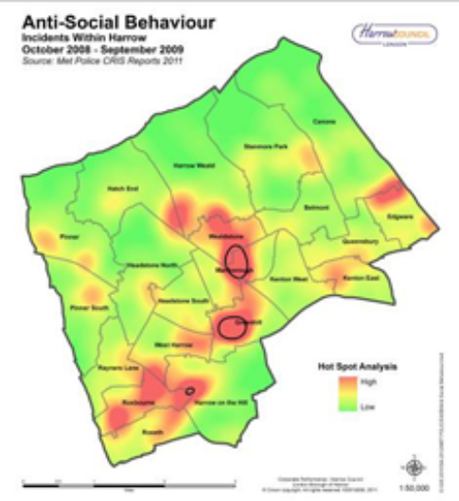Fig.6 covering incidents between 2008-2009

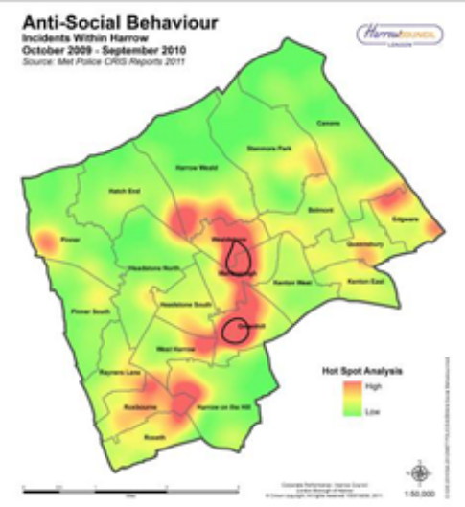 Fig. 7 covering incidents between 2009-2010

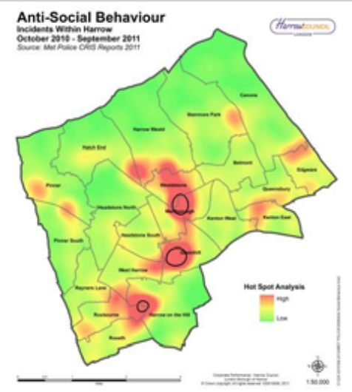Fig.8 covering incidents between 2010-2011
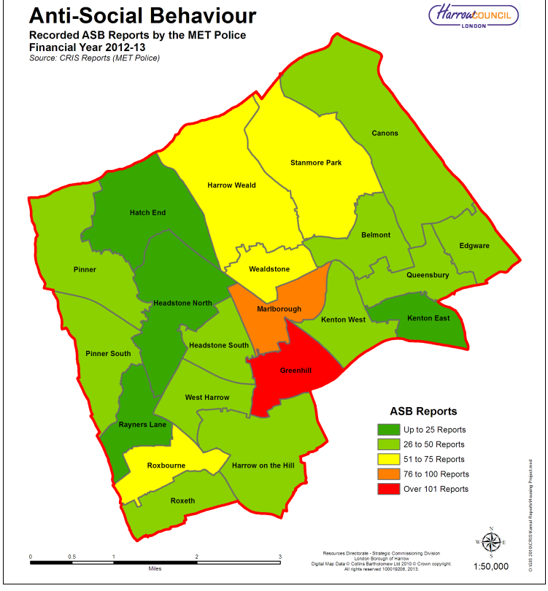 Fig. 9 covering incidents between 2012-2013

Although the Metropolitan police in Harrow have not recorded the tenure in domestic ASB incidents reported to them, the clustering of crime and ASB incidents coinciding with the area of Roxbourne and Roxeth where there have been a large number of complaints about private rented housing (see section titled Private Rented housing stock in this chapter) cannot be ignored. The police ASB data is reflected by Harrow council ASB data where the cases investigated by the council provide a clearer link between the private rented stock and ASB in the proposed designated area.

ASB Reports Received by Harrow Council

Between the 2012-2013 financial year, the Council’s anti-social behaviour team received a total of 359 complaints. The breakdown of the complaints between the two year period of 2011-2013 shows that the most frequent complaint was nuisance behaviour across most wards and Roxbourne ward was the highest to receive complaints.

Table 1 below covers a three year period and shows that the ASB for Roxbourne more than doubled between 2008-2011. Roxbourne and Roxeth have both been above the borough average for ASB throughout the three year period between 2008-2011.

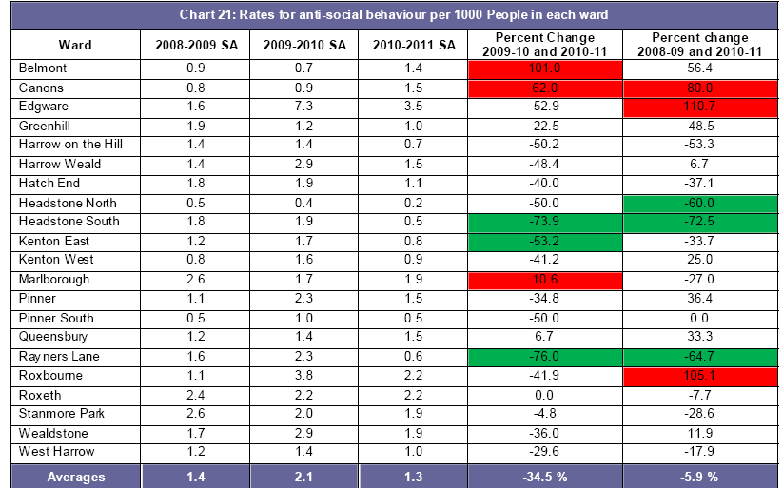
Table 1: showing data received by Harrow council. Taken from the Harrow Strategic Assessment 2012

As shown in figure 10 below, the worst recorded rate of ASB was found to be located in the eastern lower super-output area of Roxbourne ward which includes the South Harrow Area.

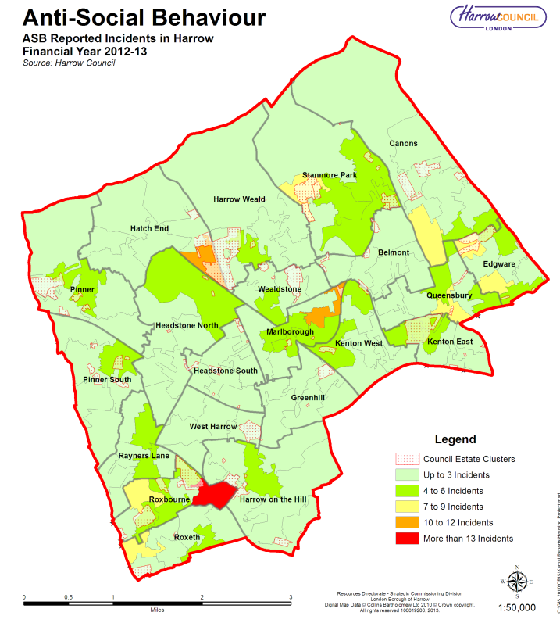
Fig.10
To analyse the data for the purpose of this proposal, all complaints not relating to a specified residential address were removed from the list of complaints received for the financial year of 2012-2013 and the remaining addresses were cross-referenced with council tax data to determine how many ASB complaints related to private rented properties. It was found that for Roxbourne ward, 11 out of 18 (61%) complaints of this nature definitively came from the private rented stock and mostly related to nuisance behaviour. Nearly all of the problem properties were based in the proposed designated area.

While the pool of council ASB complaints is eclipsed by that received by the police, the latter handles longstanding cases that when resolved, can have a profound effect on the local area.

Environmental Anti-Social Behaviour

The following maps covering 2008-2011 (figures 11-13) show hotspots of environmental crime such as fly-tipping and noise within a 1km radius of the centre of South Harrow for the last three years. There is a much dispersed cluster of hotspots in the circle.

The following chart illustrates the number of publicly reported reports received by Harrow Council for each of the last three years and the percent change for each year within the South Harrow area. The top complaint for the 2010 - 2011 periods was that of fly tipping where it has seen an increase of 15.1% against the previous year. Within this area anti-social behaviour reported to the council has been relatively low compared to that received by the police but contained nearly 10.1% of all reports made to the council for the borough. From the total number of complaints received by the council in this area, fly tipping and noise made up nearly 57% of the complaints to the council. When comparing the total number of reports during the past three years, South Harrow (i.e. Roxbourne and Roxeth) received 7.9% of the complaints to the council.

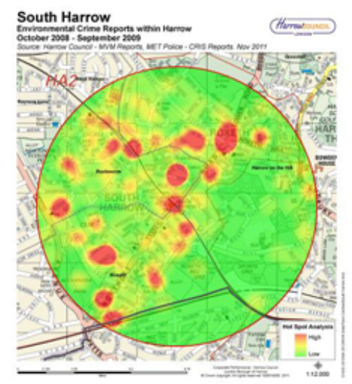Fig. 11 covering 2008-2009 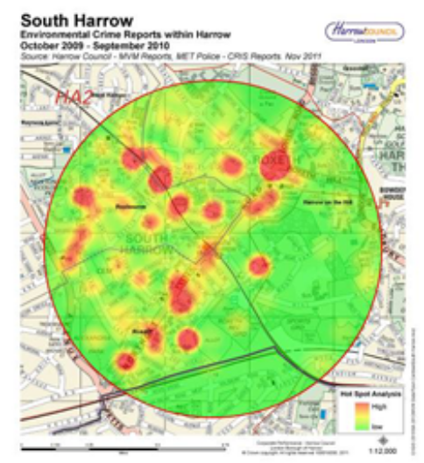 Fig. 12 covering 2009-2010
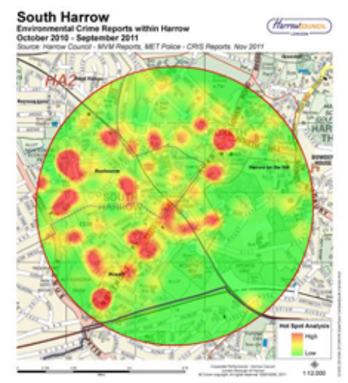Fig.13 covering 2010-2011

The Audit Commission found that fear of crime is fuelled by dirty streets cluttered by abandoned cars and anti-social behaviour such as noisy neighbours. Roxbourne ward has been affected by higher than average levels of nuisance/abandoned vehicles and has a very high proportion of noise nuisance complaints as the next section reveals.

Noise nuisance
Table 2 illustrates the number of noise complaints that were received by the council during the three time periods of the Strategic Assessment by each ward. For all three years Roxbourne had a rate higher than the Harrow average.

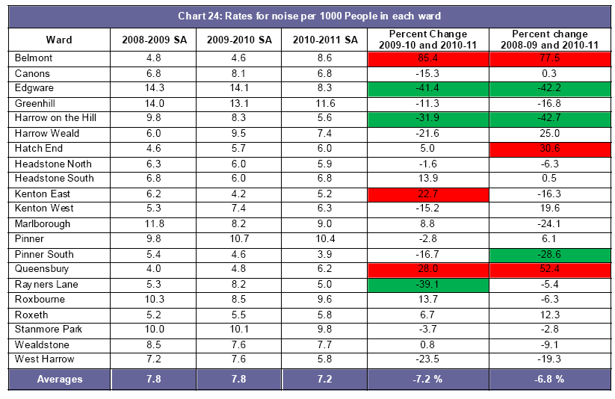
Table 2

A more in-depth map looking at super output areas below reveals that the eastern part of Roxbourne adjacent to Northolt Road is the most affected by noise nuisance in south Harrow and this is where the most number of private rented properties is concentrated in this ward.

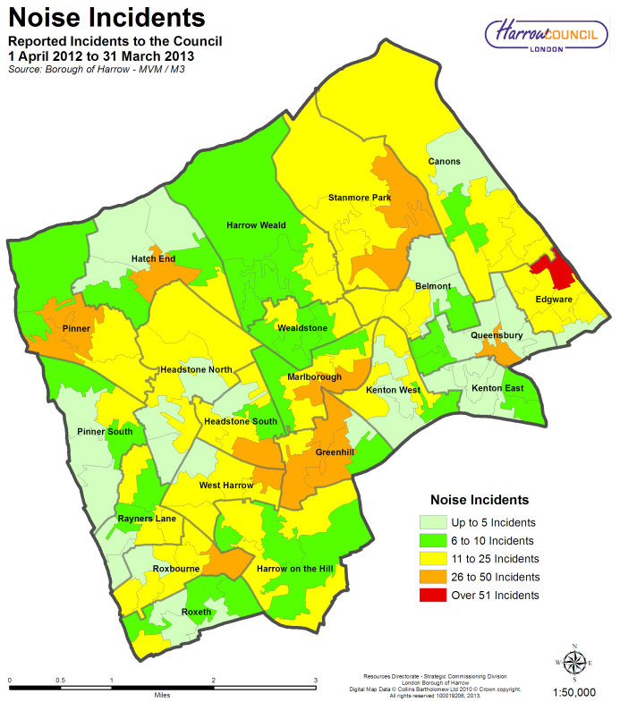

Fig.14

Closer analysis of the most recent data reveals that of the 89 noise complaints that the council received for Roxbourne ward (excluding commercial noise), 40% were as a result of noise originating from privately rented properties (see table below).

No. of complaints from the public for Roxbourne ward by tenure for 2012-2013
Tenure | No. of Noise Complaints | Percentage of Total
Unknown | 1 | 1 %
Council | 26 | 25%
Private Rented | 41 | 40%
Owner-Occupied | 21 | 20%
Registered Social Landlord | 14 | 13.6%
Table 3

These figures help to build up a consistent picture of crime and ASB in the designated area.

3.1 Summary of key facts

In the wards in which this designated area is proposed:

Roxbourne ward

- Higher than average crime rate
- Higher than average ASB rate
- High volume of noise complaints
- High volume of benefit dependent households
- High turnover of residents
- Large volume of service requests for Council intervention regarding private rented properties
- Large number of overcrowded properties
- Number of residents citing poor health is worse than borough average

Roxeth

- High rate of crime
- High rate of ASB
- High volume of noise nuisance
- Large number of overcrowded properties
- Average number of residents in poor health

3.2 The Wealdstone High Street Area
The proposed area (bordered in green below) straddles the following wards: Wealdstone and Marlborough

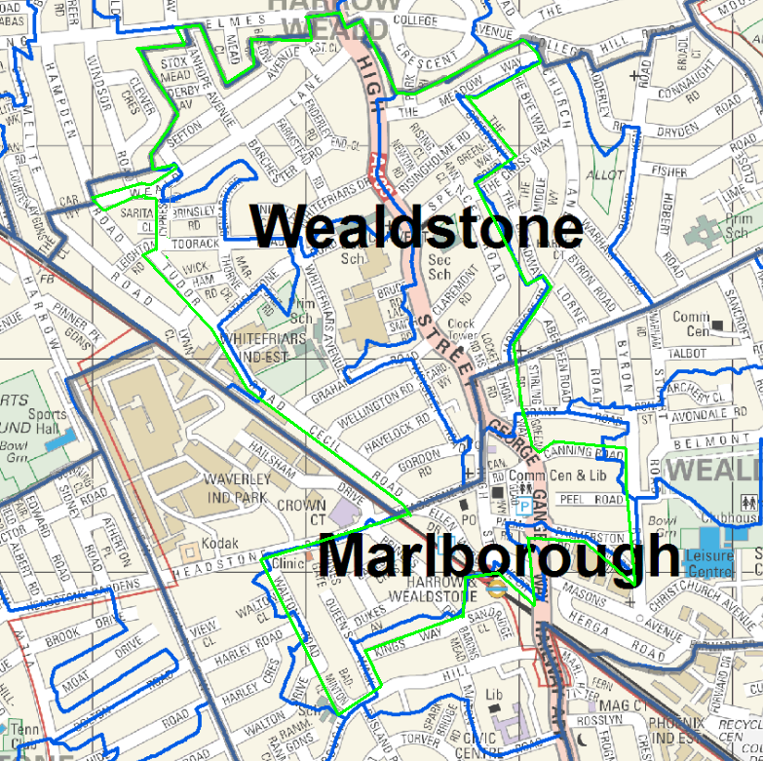
Fig.15

Crime and Anti-Social Behaviour
The area suffers from a number of fires both deliberate and accidental each year. Out of the 100 fires in Wealdstone 86 were deliberate and out of 99 fires in Marlborough 76 were deliberate. Together these two wards made up 10.3% of the total deliberate fires in Harrow for 2012-2013.

During the previous tax year of 2012-2013, Marlborough ward suffered the highest incidents of ambulance call outs resulting from weapon injuries and the second highest from physical assault.

For serious violent offences, both Marlborough and Wealdstone consistently are among the wards with above average rates with the highest rates after Greenhill ward for the last several years running.

The Wealdstone High Street area was named in the 2011-2012 Harrow Strategic Assessment as one of three chief hotspots for crime and anti-social behaviour in Harrow. The following maps in figures 16, 17 and 18 include all recorded crime in a 1km radius of Harrow Town Centre for the last three years. The pattern is relatively consistent over the three year period. There is a high degree of continuity over the three year period and most incidents are along the Wealdstone High Street.
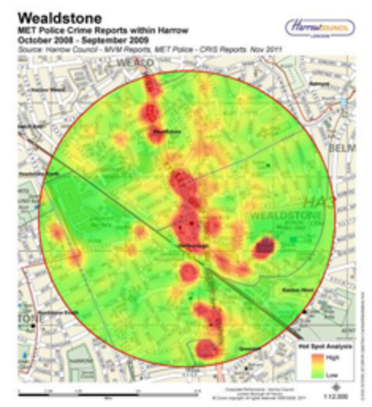Fig.16 covering 2008-2009 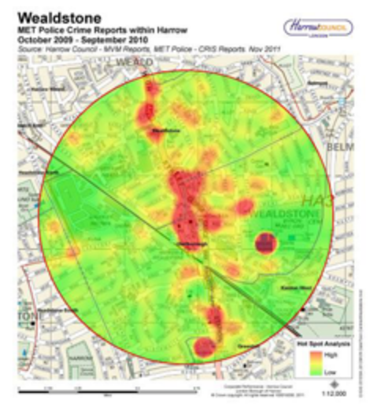Fig. 17 covering 2009-2010 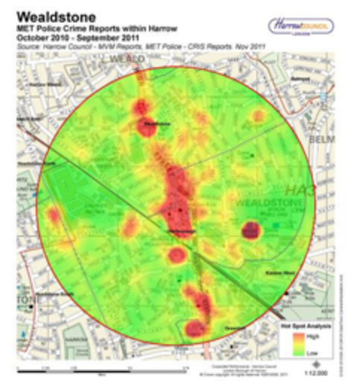Fig.18 covering 2010-2011

The north of Marlborough where it borders Wealdstone is particularly high for police call outs as the map below displays.

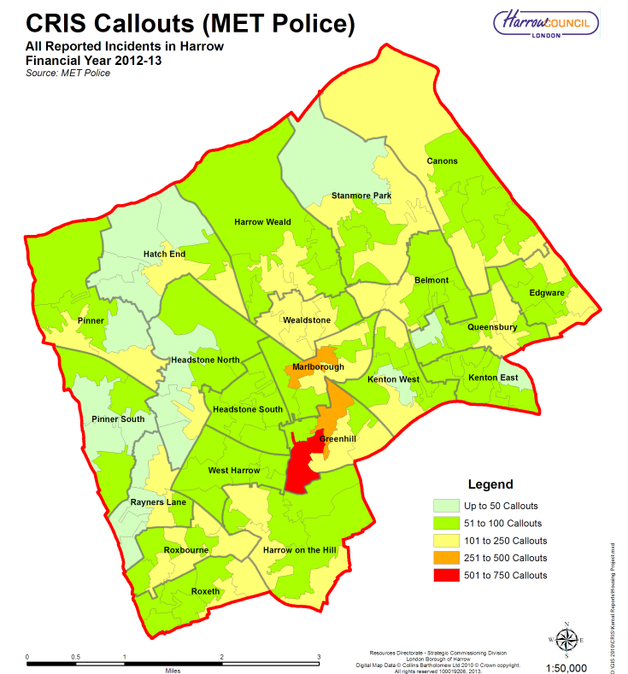

Fig. 19

ASB Reports Received by the Police

The figure below depicts the volume of ASB reports per ward in the last financial year and shows that Marlborough and Wealdstone are among the highest wards for the previous financial year.

Fig. 20
The overall rate per 1000 of ASB reports have declined in recent years but Marlborough ward has had an extremely higher than average rate of police call outs for ASB than Harrow on the whole and this trend has been consistent for the last four years. For the year 2012-2013 the average rate of ASB call outs in Harrow was 4.1 compared to Marlborough and Wealdstone wards’ significantly higher rate of 7.6 each. The clustering of the incidents in the following maps charting the spread of ASB through the years beginning for 2008-09 illustrates that the majority of the problems for these wards is clustered along the Wealdstone High Street area which crosses both these wards.

The figures 6, 7, 8 and 9 in this report show the hot spots of ASB in the borough over the last four years

ASB Reports Received by Harrow Council

Marlborough and Wealdstone have had extremely high rates of ASB in every year from 2008 (see table 1).

The spread of ASB passes through Marlborough to central Wealdstone as the map in figure 10 illustrates.
To analyse the data for the purpose of this proposal, all complaints not relating to a specified residential address were removed from the list of complaints received for the financial year of 2012-2013 and the remaining addresses were cross-referenced with council tax data to determine how many ASB complaints related to private rented properties. It was found that for Wealdstone ward and Marlborough, 7 out of 12 (58%) and 9 out of 14 (64%) ASB complaints respectively originated from private rented tenants and mostly related to nuisance behaviour. Many of the problem properties were based in the proposed designated area.

Environmental Anti-Social Behaviour
The following maps covering 2008-2011 (figures 21-23) show hotspots of environmental crime such as fly-tipping and noise along Wealdstone High Street. There is a much dispersed cluster of hotspots in the circle.

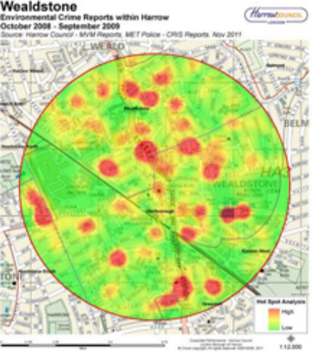Fig.21 covering 2008-2009
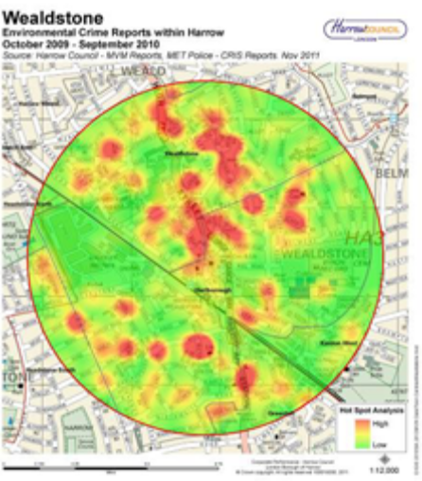Fig. 22 covering 2009-2010
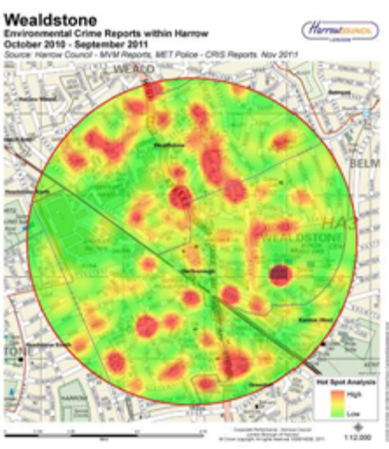Fig.23 covering 2010-2011

Marlborough ward suffers the highest incidents of both fly tipping and graffiti. The statistics from the previous tax year shows that 1,259 out of 8,139 fly tipping incidents and 68 out of 439 graffiti incidents originated from Marlborough ward.

The following maps (figures 68 through 70) illustrate the number of noise complaints that were received by the council during the three time periods of the Strategic Assessment by each ward. For all three years Marlborough has had a higher than average rate of noise complaints. Wealdstone’s rates have been fairly close to the average (see table 2 in page 17).

Noise nuisance

In 2012-2013, Marlborough was the seventh highest for noise complaints received by the council. Closer analysis of the most recent data reveals that of the 51 noise complaints that the council received for Wealdstone and 66 for Marlborough (excluding commercial noise), 54.9% and 43.9% respectively were as a direct result of noise originating from privately rented properties (see table below).

No. of complaints from the public for Wealdstone ward by tenure for 2012-2013
Tenure | No. of Noise Complaints | Percentage of Total
Council | 7 | 13.7%
Private Rented | 28 | 54.9%
Owner-Occupied | 14 | 27.5%
Registered Social Landlord | 2 | 3.9%
Total | 51 | 100%
Table 4

No. of complaints from the public for Marlborough ward by tenure for 2012-2013
Tenure | No. of Noise Complaints | Percentage of Total
Council | 3 | 4.6%
Private Rented | 29 | 43.9%
Owner-Occupied | 30 | 45.5%
Registered Social Landlord | 4 | 6.1%
Total | 66 | 100%
Table 5

These figures help to build up a consistent picture of crime and ASB in the designated area.

Summary of key facts

In the wards in which this designated area is proposed:

Marlborough
- High ambulance call outs for weapon injuries and physical assault
- Large number of deliberate fires
- Higher than average serious violent crime
- Higher than average rates of ASB
- Higher than average rates of noise nuisance
- High number of fly-tipping and graffiti incidents
- High population turnover
- Large number of benefit dependent households
- Large number of private rented properties
- Large number of category 1 hazards when compared to other Harrow wards
- Large volume of service requests for Council intervention regarding private rented properties
- Large number of overcrowded properties

Wealdstone
- Large number of deliberate fires
- Higher than average serious violent crime
- Higher than average rate of ASB
- Average rate of noise nuisance
- High population turnover
- Large number of category 1 hazards when compared to other Harrow wards
- Large volume of service requests for Council intervention regarding private rented properties
- Large number of overcrowded properties

3.3 The Edgware Area
The proposed area is the Edgware ward

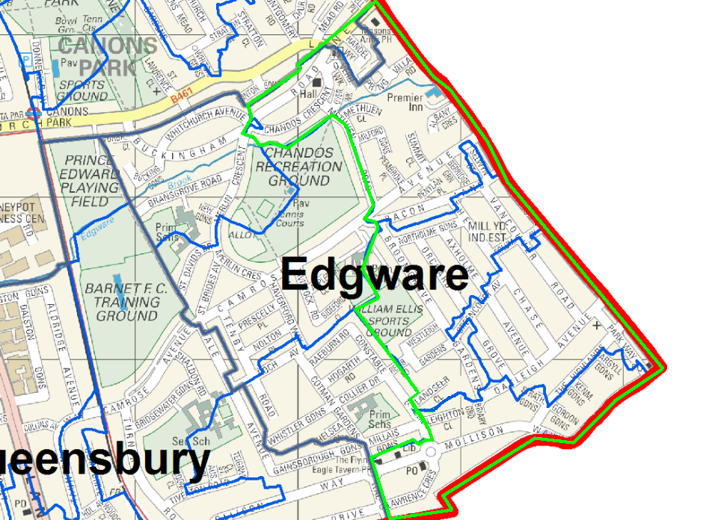
Fig. 24

Crime and Anti-Social Behaviour
The area suffers from a number of fires both deliberate and accidental each year. Out of the 86 fires in Edgware 76 were deliberate and out of 99 fires in Marlborough 76 were deliberate which is 6% of the total deliberate fires in Harrow for 2012-2013.

Edgware consistently is among the wards with above borough average rates for serious crime. The eastern part of Edgware ward along Burnt Oak Broadway was named in the 2011-2012 Harrow Strategic Assessment as one of the main hotspots for crime and anti-social behaviour in Harrow. The following maps in figures 31, 32 and 33 below include all recorded crime in a 1km radius of Harrow Town Centre for the last three years. The pattern is relatively consistent over the three year period. There is a high degree of continuity over the three year period and most incidents are among the housing estate on and around the vicinity of Burnt Oak Broadway.
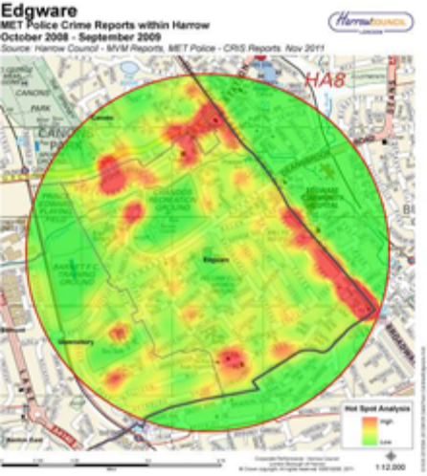Fig. 25 covering 2008-2009 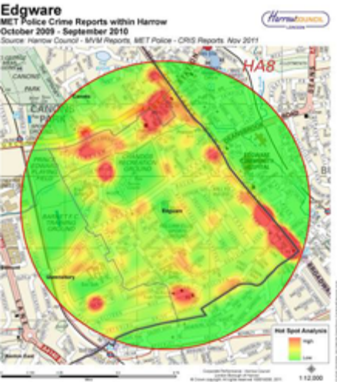Fig. 26 covering 2009-2010 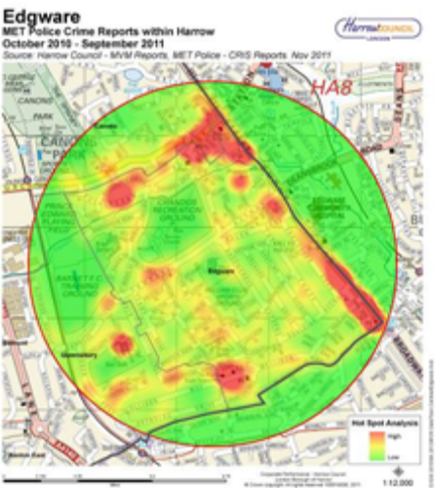Fig.27 covering 2010-2011

ASB Reports Received by the Police

The overall rate per 1000 persons of ASB incidents have declined in recent years but Marlborough ward has had an extremely higher than average rate of police call outs for ASB than Harrow on the whole and this trend has been consistent for the last four years. For the year 2012-2013 the average rate of ASB call outs in Harrow was 4.1 compared to Edgware’s rate of 4.6. The clustering of the ASB incidents in figures 6, 7 and 8 (see page 12) indicate that such problems in Edgware seem to occur along Burnt Oak Broadway and Whitchurch Lane.

ASB Reports Received by Harrow Council

Edgware has very high rates of ASB being always greater than the borough average. The rate of ASB more than doubled between the years 2008-09 and 2010-11.

The spread of ASB reports to Harrow council show more prominence in the north-east corner and south of Edgware (see map depicting this in figure 10 on page 15).

To analyse the data for the purpose of this proposal, all complaints not relating to a specific residential address were removed from the list of complaints received for the financial year of 2012-2013 and the remaining addresses were cross-referenced with council tax data to determine how many ASB complaints related to private rented properties. It was found that for Edgware, 7 out of 21 (33%) ASB complaints originated from private rented tenants and mostly related to nuisance behaviour.

Environmental Anti-Social Behaviour
The following maps from the Harrow Strategic Assessment 2012 (figures 34 - 36) show hotspots of environmental crime such as fly-tipping, noise and ASB in Edgware. The maps suggest that the problems are concentrated along Burnt Oak Broadway and in the housing estate west of it and that this pattern has been consistent over the years.

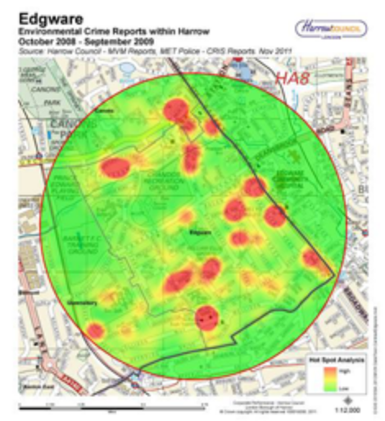Fig.28 covering 2008-2009
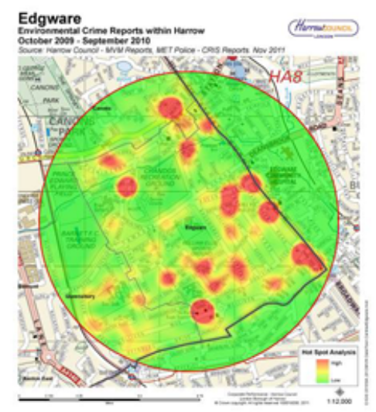Fig. 29 covering 2009-2010
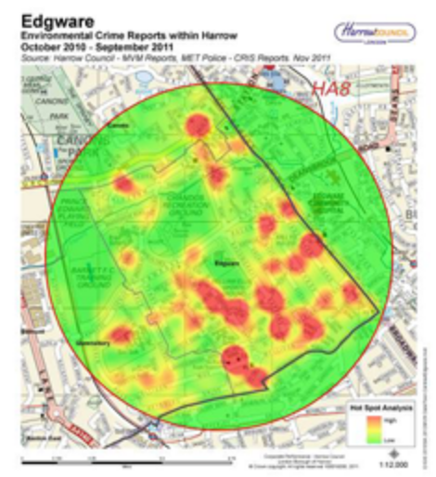Fig.30 covering 2010-2011

Edgware suffered from a high number ward fly tipping incidents many of which was domestic waste accounting for 9% of the total fly tipping that occurred in Harrow between 2012-2013 and exceeding the borough average of 388 incidents per year.

Noise nuisance

Table 2 on page 17 shows that the number of noise complaints for Edgware has been above average for several years running although it has declined significantly in recent years. However, when the incidents are plotted for Edgware, it becomes clear that this ward is relatively low in reported noise nuisance except the north eastern corner which is the highest area affected by noise nuisance in the whole of Harrow (see map in figure 14 on page 18)

In 2012-2013, Edgware was the third highest for noise complaints received by the council. Closer analysis of the most recent data reveals that of the 82 noise complaints that the council received for this ward 59.8% were as a direct result of noise originating from private rented properties (see table below).

No. of complaints from the public for Edgware ward by tenure for 2012-2013
Tenure | No. of Noise Complaints | Percentage of Total
Council | 12 | 14.6%
Private Rented | 49 | 59.8%
Owner-Occupied | 17 | 20.7%
Registered Social Landlord | 4 | 4.9%
Total | 82 | 100%
Table 6

These figures help to build up a consistent picture of crime and ASB in the designated area.

Summary of key facts

In the wards in which this designated area is proposed:

Edgware
- Large number of deliberate fires
- Hotspot for serious crime and ASB
- Consistently Higher than average ASB incidents both on Met Police and Harrow council databases
- A designated hotspot for environmental ASB particularly for fly tipping
- Large volume of noise nuisance from private rented properties complaints particularly in north eastern part of Edgware

4. Housing Demand

Section 80(4) of the Housing Act 2004 requires local authorities to take account of the following factors when deciding whether an area is ‘subject to low housing demand’:

- the value of residential premises in the area, in comparison to the value of similar premises in other areas which the authority consider to be comparable (whether in terms of types of housing, local amenities, availability of transport or otherwise);

- the turnover of occupiers of residential premises;

- the number of residential premises which are available to buy or rent and the length of time for which they remain unoccupied.

DCLG guidance (also advises that the additional factors below can be investigated to assess housing demand:

- A lack of mixed communities in terms of tenure, for example, a high proportion of rented property, low proportion of owner occupied properties.
- A lack of local facilities, for example, shops closing down.

- The impact of the rented sector on the local community, for example, poor property condition, anti-social behaviour etc.

- Criminal activity.

The Value of Residential Premises in the Area

Using ward level data was considered too large to provide geographically comparable areas for comparison of house prices. The Census 2011 does not provide data for house prices at the LSOA level so the next smallest boundary level was used which was MSOA level. MSOAs covering each of the three proposed areas plus three other similar areas (i.e. located near a tube station and with a high street) were used. The figure below depicts the prices of a variety of dwelling types in each MSOA.

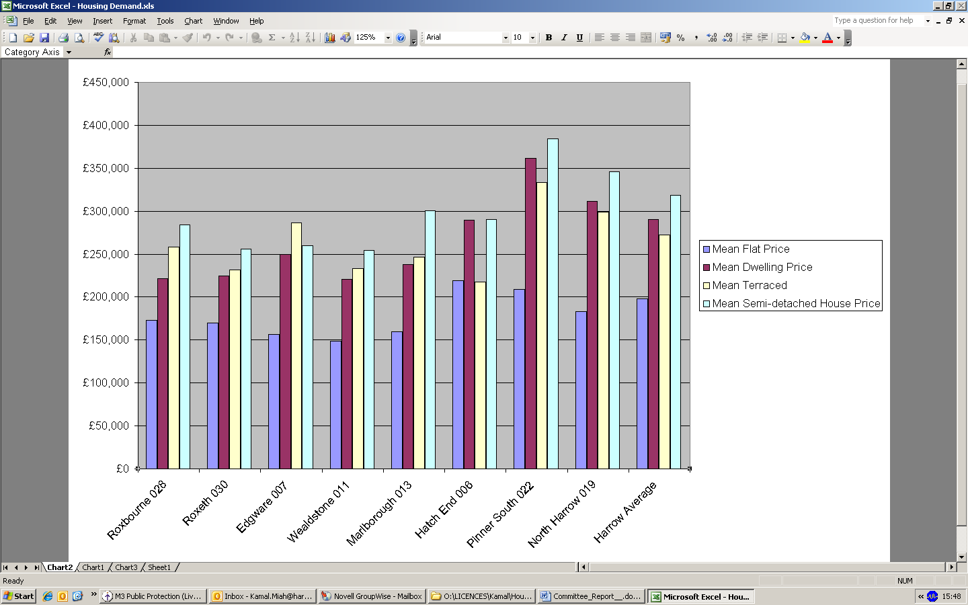
Fig. 31

The average prices of different dwelling types in each of the selected MSOAs illustrates that property prices are much lower in the proposed areas than the same dwelling types located in other areas with comparable amenities as well as being cheaper than the borough averages.

The figure below illustrates that the tenure composition for these areas. It can be seen that the number of private rented properties is greater in the proposed areas than in the comparable areas of Hatch End, Pinner South and North Harrow.

The trend suggests that areas with a higher concentration of private rented properties also tend to have depreciated house prices. These areas also suffer from poor quality private rented housing and social deprivation which evoke a negative impact on the value of housing, turnover of residents and quality of life as later sections will elaborate.

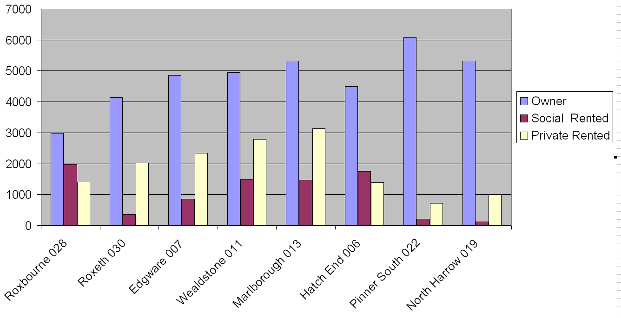
Fig. 32

Population turnover and Deprivation in Roxbourne and Roxeth

The population in the area is particularly transient. The graph below shows the six mid-super output levels (MSOAs) in Harrow with the highest negative turnover rates for the 2008-2009 year taken from the Census 2011. It reveals that this part of Roxbourne which covers the proposed area has the highest negative churn (which was -21 per 1000 persons) i.e. more leaving than entering was within Roxbourne ward covering the South Harrow Area. This negative outflow has been consistent for the preceding several years suggesting that many residents feel no ties to the local area, community spirit is found wanting and that the quality of life is relatively poorer here.

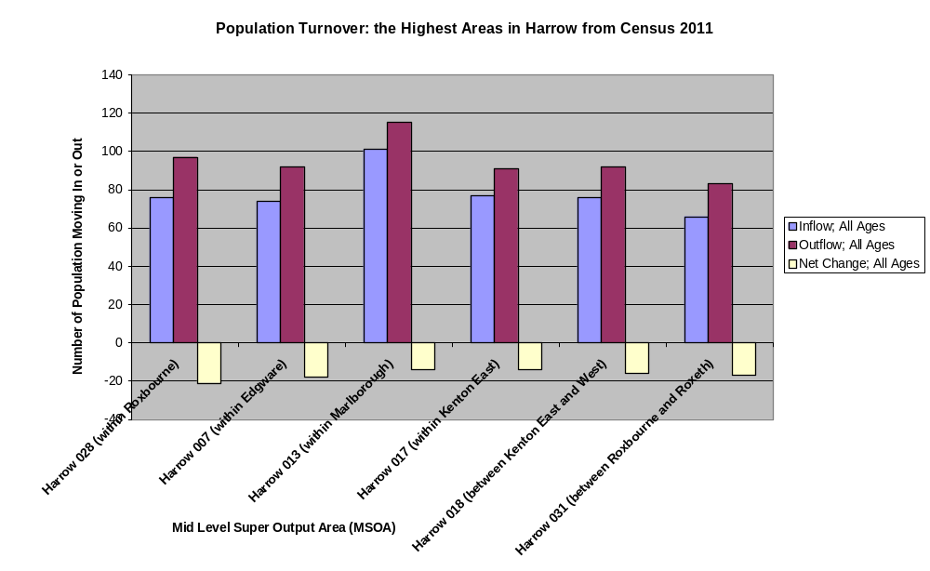
Fig.33

Benefit Dependency

Roxbourne ward has one of the highest number of lone parent households in work but receiving child tax credit and the highest number of claimants for jobseeker’s allowance and income support than any other ward in Harrow.
In 2011, Roxbourne ward was found to have the highest number of children in out-of-work families.
While the number of lone parent households with dependent children in Roxeth dropped between 2001 to 2011, the opposite trend has been observed for Roxbourne. In 2001, there were a total of 442 lone parent households with dependent children in Roxbourne and in 2011 this number rose to 500, 49% of whom were unemployed, higher than the borough average of 43%.
5% of Harrow’s council tax benefit and housing benefit claimants live in Roxeth. 8.3% live in Roxbourne. The vast majority of these claimants are either single or a couple.
6.5% JSA claimants live in Roxeth while 7.7% live in Roxbourne.

Health

5.4% of the Roxbourne’s population regarded themselves as having either bad health or very bad health which is much higher than the borough average of 4.6%. The margin between the borough average and Roxbourne’s average for poor health has widened from 2001 to 2011.

The Private Rented Housing Stock

As of the 2011 Census, Roxbourne has a total of 1069 privately renting which is much higher than the borough average. Roxbourne ward’s private rented residents make up 23.7% of the ward’s residents while Roxeth’s makes up 25.7% of its population.
Most of the private rented housing in Roxbourne and Roxeth is contained within the following super out areas depicted below which flank Northolt Road and Eastcote Lane.

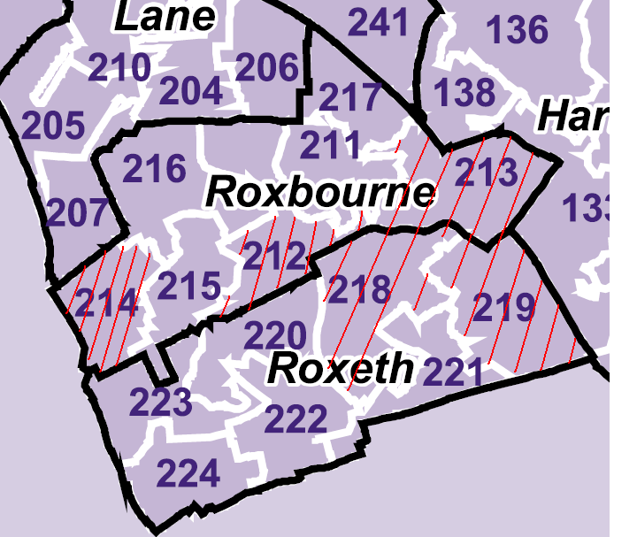

Fig. 34

Although Roxbourne and Roxeth overall generated lower service requests to the Private Sector housing enforcement team, the vast majority of these were densely populated in the South Harrow Area (see map below showing the area highlighted yellow and orange across Roxbourne and Roxeth south of Harrow).

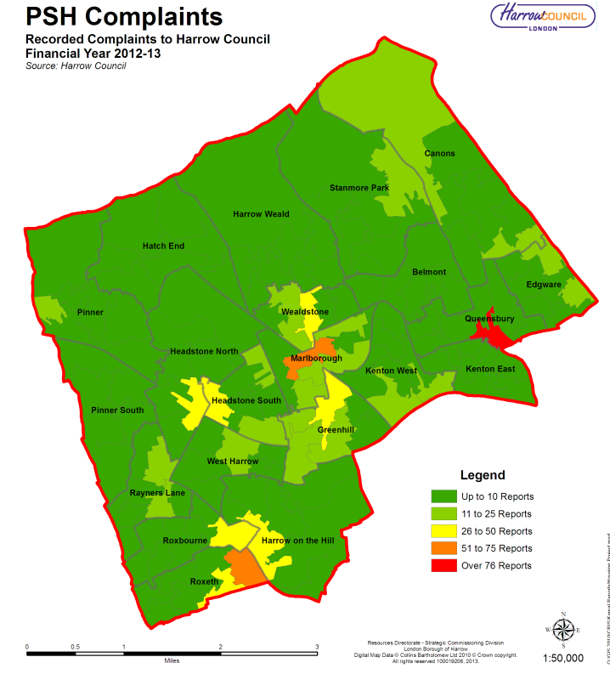
Fig. 35

Of the 57 service requests received for Roxbourne ward, 53% were directly as a result of the condition of the property the complainant was living in.
The occupancy rating in the Census 2011 which measures overcrowding by looking at how many households required at least one extra bedroom reveals that 14.5% and 13% of the borough’s overcrowded households lived in Roxbourne and Roxeth respectively (see figure below).

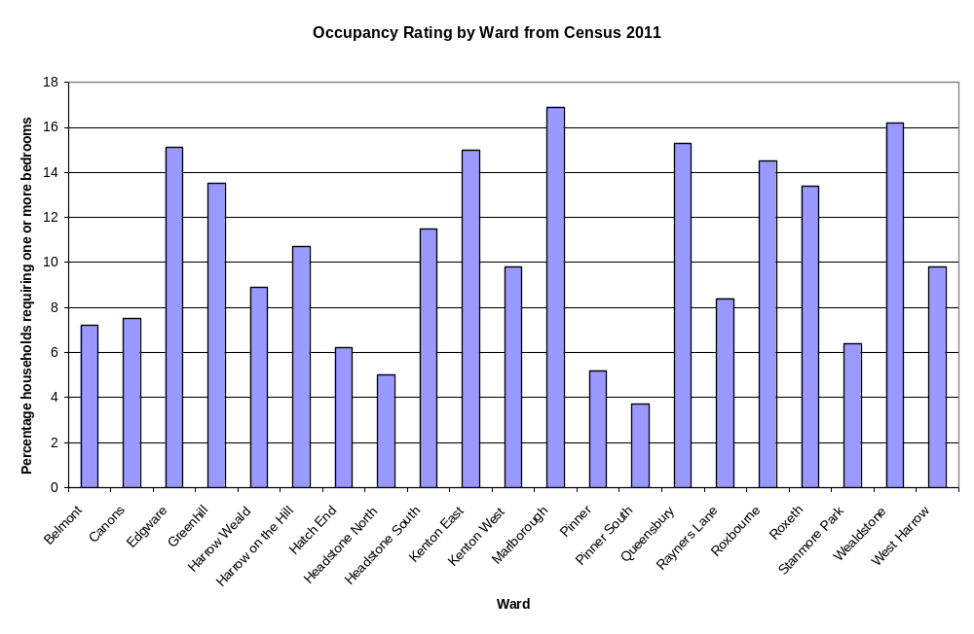
Fig. 36

All of this details a picture of an area experiencing a mix of poor housing with a large number of housing standards complaints of which a significant percentage are the result of landlord negligence and where a disproportionately large number of households are benefit dependent and have social problems reflected by this. In fact, a report published by the Audit Commission in 2006 reported that one in three people living in more deprived areas thinks that anti-social behaviour is damaging their quality of life.

All of the above indicate that both council wards in which the designated area is located suffer from higher rates of crime and deprivation than Harrow as a whole.

Population turnover and Deprivation in Marlborough and Wealdstone

A population high turnover makes it harder to create ties with the local area and nurture a community spirit which facilitates greater care and pride for the place residents live in.
Marlborough ward contains the MSOA with the highest number of people entering and leaving its boundary based on the findings of the Census 2011, although the evidence indicates that more people leave then enter creating a negative flux of migration. This MSOA borders Wealdstone and had a net change rate of -14 per 1000 persons.

Marlborough is the third highest ward in Harrow for children in out of work families and also the third highest for children in families receiving either income support of jobseeker’s allowance.

Marlborough has the second highest claimants for jobseeker’s allowance.

According to the Census 2011, the number of lone parent households with dependent children in both Marlborough and Wealdstone increased from 2001 to 2011. In Wealdstone out of 399 lone parent households with dependent children 46.9% were unemployed while in Marlborough 387 47.8% were unemployed. Both higher than the borough average of 43.5%
Marlborough and Wealdstone’s number of households on housing benefit and council tax benefit (950 and 1,140 respectively) far exceeds the borough average of 677. 6% of Harrow’s council tax benefit and housing benefit claimants live in Marlborough while 7.3% live in Wealdstone. The vast majority of these claimants are either single or a couple.

The number of claimants for jobseeker’s allowance in Marlborough (275) and Wealdstone (173) also significantly surpasses the borough average of 128.

Health

According census data, 4.7% and 4.8 of the Marlborough’s and Wealdstone’s population respectively regarded themselves as having poor health which is slightly higher than the borough average of 4.6%.

Housing stock

As of the 2011 Census, Marlborough has the second highest number of privately rented properties (30.8% of the ward’s housing stock) has the fourth highest (26.9% of Wealdstone’s stock). The super output areas in Marlborough and Wealdstone with high number of private rented properties are shown below in figure 28 flanking Wealdstone High Street.

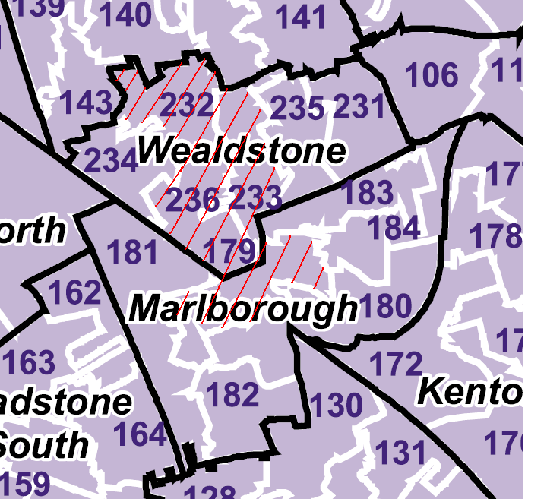
Fig.37

Marlborough generated the most service requests to the Council’s Private Sector Housing Enforcement team in the previous financial year. Wealdstone was also on the higher than most wards.

Of the 132 service requests received for Marlborough and 100 service requests for Wealdstone, 47.7% and 53% respectively were directly as a result of the condition of a private rented property.

Marlborough and Wealdstone also among the most number of identified category one hazards under the Housing Act 2004 (see figure 29 below), mostly attributed to excess cold, damp and mould and crowding and space. These hazards can affect the morale of people living in such conditions and influence how people feel about where they live.

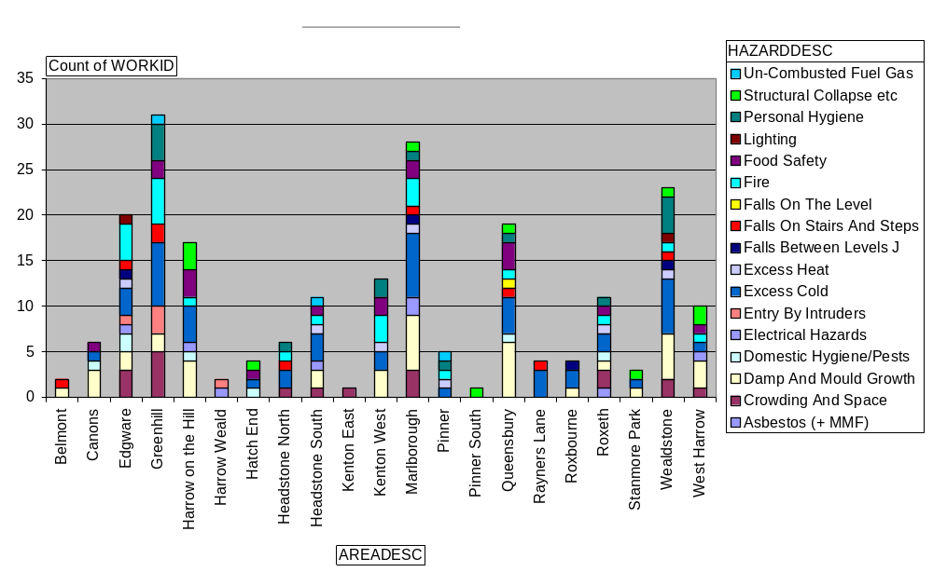
Fig. 38

The occupancy rating in the Census 2011 reveals that Marlborough and Wealdstone were the highest for overcrowded households than any other ward.

Population turnover and Deprivation in Edgware

The population of Edgware is very transient, with a high turnover and one of the lowest negative churn rates (-18) in Harrow (see figure 15 for graph on page 20).

In 2009-2010 which is the earliest data, the MSOA which covers most of Edgware and all of the proposed area for designation, 74 people came to live there while 92 migrated out of the area. The area has consistently had a negative rate of net migration change for several years running.

In earlier sections of this report, it has been highlighted that a transient community presents less attachment and commitment/care for the local area and is often an indicator for deprivation and poor quality of life.

Benefit Dependency

According to the Census 2011, there were 253 lone parent households with dependent children in Edgware and 49.4% were unemployed which was higher than the borough average of 43.5%.
Census data also reveals that there were 870 households (making up 5.6% of the total claimants of Harrow) on housing benefit and council tax benefit which significantly exceeds the borough average of 677. The vast majority of these claimants are either single or a couple.

The number of claimants for jobseeker’s allowance (JSA) in Edgware (155) also surpasses the borough average of 128, making up 5.8% of the borough’s JSA claimants.

Health

4.5% of Edgware ward’s population regarded themselves as having poor health which is slightly lower than the borough average of 4.6%.

Housing stock

24.5 % of the housing stock in Edgware is privately rented.
Most of the private rented housing in Edgware is along the following super out areas below which coincides with where crime and environmental ASB is occurring in this ward.

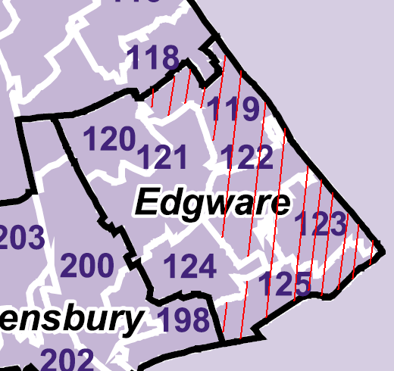
Fig. 39

Edgware generated 69 complaints/ service requests to the Council’s Private Sector Housing Enforcement team in the previous financial year which was not as high as other wards like Marlborough and Wealdstone but greater than the borough average of 62.5 but it must be borne in mind that Edgware has a smaller private rented housing stock than these other wards.

Of the 132 service requests received for Edgware 59% were directly as a result of the condition of a private rented property.

In 2012-2013, Edgware had an above average number of category 1 hazards, mostly attributed to excess cold, fire, damp and mould and crowding and space (see figure 38).

The occupancy rating in the Census 2011 revealed that 15.1% of households in Edgware are overcrowded (i.e. 562 households), one of the highest figures in Harrow and well above the borough average 421 households.

5. Conclusion

Local authorities can decide to designate a Neighbourhood Improvement Scheme either because they have areas of low housing demand and/or are experiencing “a significant and persistent” problem of anti social behaviour in an area. It has been proven that both these conditions apply to Harrow.

This report has identified that there are higher than average levels of unemployment, poor health, crime and ASB compounded high population turnover and social deprivation in these three proposed areas. Consequently it is not strange that these areas are recognised as being rundown and adding adversely to the overall reputation of Harrow.

Cheaper housing in places of low demand have attracted unprofessional landlords into the area who exhibit little interest in responsible management of their rented properties, often letting problems originating from their tenants go on without care. This has can create destabilisation and lead to unhappiness for the local community.

Low housing demand is occasionally caused and certainly worsened by ASB. Evidence has been produced in this report to link the private rented sector in each proposed area as a contributing factor in ASB incidents. It has also been observed that in areas with a low percentage of private rented properties, the value of housing is higher. This indicates that the private rented housing in the proposed areas is having an adverse effect on the value of local housing.

Therefore, implementing this scheme will tackle the problems of low housing demand and ASB by involving landlords more closely in the running of their properties in a responsible way and taking to task misbehaving tenants.

Why a change is needed

Local authorities can decide to designate a Neighbourhood Improvement Scheme either because they have areas of low housing demand and/or are experiencing “a significant and persistent” problem of anti social behaviour in an area. The former does not apply to Harrow as house prices have risen across the borough but the latter does.

This report has identified that there are high levels of unemployment, poor health, high levels of crime and ASB, high population turnover and social deprivation in these three proposed areas. Consequently it is not strange that these areas are recognised as being rundown and adding adversely to the overall reputation of Harrow.

Evidence has been produced in this report to link the private rented sector in each proposed area as a contributing factor in ASB incidents. Therefore, implementing a Neighbourhood Improvement Scheme will tackle the problems by involving landlords more closely in the running of their properties in a responsible way and taking to task misbehaving tenants.

A House of Commons Report titled ‘Selective Licensing of Privately Rented Housing’ stated that in areas where selective licensing had been implemented, those areas had the largest increase in house prices.

What’s in it for Landlords?

While some landlords are responsible, others are not. This will substantiate the council’s position of wishing to support cooperative, decent landlords.

The Neighbourhood Improvement scheme will aim to work with landlords to establish good practice and to help landlords reach the most optimal outcomes in any problems regarding managing their properties.

We anticipate some landlords will protest at having to pay for a licence if they are good landlords who simply let a property in the designated area and feel that they are being they are being unfairly grouped with poor landlords but this would be a misconception. The Neighbourhood Improvement Scheme creates a level playing field for all landlords in the designated area so poor landlords will find it harder to get away with undercutting good landlords by providing cheap, ill-conditioned accommodation. Every landlord will be treated fairly and receive the same support. Furthermore, as the licence period is five years, there is no guarantee that presently good landlords will not become complacent overtime and rather than trying to identify good landlord from bad landlord, this scheme is designed to create a culture of good practice across the whole area and therefore, all landlords operating therein will have to be licensed.

The scheme is not to be seen as a tax for landlords. It is an opportunity for a close mutually-beneficial partnership with the council to monitor and regulate the area. For example, support can be provided for landlords finding it hard to abide by licence conditions or need help dealing with anti-social tenants.

Ultimately, it is hoped that as the condition of the private rented stock improves and the reputation of private landlords increases it will create stable communities and raise the rental value of private rented properties so that these areas become more attractive to investors. Higher rental value would lead to a more diverse community instead of being a focal point for low-income and disadvantaged households.

Based on the consultations of other councils who implemented the scheme, it is expected that the licence fee will be a chief concern for many landlords and some may intend to raise the rent and make the tenant pay as a result. However, since these are deprived areas the landlords may be hard-pressed to find tenants willing to pay the raised prices for poor quality accommodation. Rental value must increase with gradual area improvement.

Landlords may be able to apply for business tax relief for the licence fee.

6. How will the Neighbourhood Improvement Scheme help tackle ASB?

The council has been running an additional licensing scheme for several years which has shown success in raising the standards of two storey houses in multiple occupation (HMO). From this experience, the council has found that landlords who licensed their properties were more responsive to operating to a higher standard, were more concerned about making sure their properties were safe, showed cooperation and were easier to reach and obtain involvement in any matters arising from their licensed HMOs. This is why the council is extremely confident that this success can be extended to other parts of the private rented sector if the Neighbourhood Improvement Scheme were to be implemented.

All the private rented properties will be inspected to make sure they comply with minimum standards.

Landlords will be encouraged to join accreditation schemes and will receive a discounted licence fee if they have already joined one at the time of application.

The council does not condone landlords who show little or no responsibility toward their tenant’s inconsiderate behaviour so it is proposed that penalties for poor management such as reduced licence terms, stricter conditions and repercussions for breaches of such will be enforced. Late applications will result in a penalty fee so that the scheme is treated seriously by all concerned.

Landlords will be required to meet the following criteria:

- Demonstrate they are fit and proper and a CRB check may be carried out by the council to ensure that no criminal convictions exists for the applicant which could affect the management of the property e.g. sexual offences
- Have good management and financial arrangements
- Have a procedures for dealing with problem tenants including making sure all households have a written tenancy agreement
- Any additional conditions will be issued with the licence as the council sees fit for example, making sure that references are obtained for new tenants for landlords who frequently let to problem tenants

Discounts will be issued to accredited landlords and those whose properties have no category one hazards during the application inspection. This will encourage the improvement of dwelling conditions.

The Neighbourhood Improvement Scheme will facilitate a closer working relationship between the Council and landlords in the designated area. The plan is to instil an incentive to improve standards thereby providing dwellings suitable for modern times.

Harrow Council is fortunate that it has a positive relationship with a number of authorities that have already been through this process and can share best practice. It is expected that this scheme working along side other intervention projects in the area, will have a significant impact on ASB issues and consequently the housing tenure of the area.

7. Main options

Other interventions have been reviewed as alternative measures to tackle the ASB and poor management problems in the proposed areas (see below) but these do not cover the wider issues and are ad-hoc in nature. The Neighbourhood Improvement Scheme offers a multi-pronged approach to deliver long-term changes bringing together different teams within and outside the council to work together on a shared agenda of area improvement.

Do Nothing

Evidence has shown that the area is subject to conditions that require intervention, for the purpose of helping the community.

Consultation show that issues have remained in place despite other forms of intervention taking place.

In line with Council commitments and requirements of putting the community first, the option of doing nothing is not an option. If no action is taken the problems experienced in the ward are likely to continue.

Mandatory Licensing

Mandatory licensing refers to the licensing of Houses in Multiple Occupation (HMO) where the premises are three or more storey’s and occupied by five or more people who form two or more households. This licensing regime has been in place in Harrow since 2006, but only covers a small portion of the rented accommodation sector.

Despite being in place for nearly ten years, with proactive enforcement being in place, some of the issues highlighted in the evidence above have still continued to happen.

Mandatory Licensing is able to ensure that standards are in place for specific, individual premises but not able to raise them in an area per se. Therefore the use of this licensing regime alone would not meet the objectives set out by a Selective Licensing scheme.

This scheme is already in place, but only affects HMOs, and so does not deal with issues affecting the area resulting from other privately rented properties.

Additional Licensing

Additional Licensing covers Houses in Multiple Occupation not subject to the mandatory scheme noted above. In Harrow this covers two storey properties occupied by different households. Harrow has had such a scheme in place since 2010, and as the current 5 year designation ends in November 2015; a consultation on renewing this is currently open.

Again, this addresses matters of multi occupied premises, but does not ensure a consistent approach across the rented sector in an area to bring standards up.

Using the evidence base provided from the survey of the Edgware Ward (see Appendix C), only 94 of premises would fall under the additional or mandatory scheme, compared to a minimum 550 private rented accommodation that would fall within Selective Licensing.

Additional licensing is already in place in Harrow but as noted above, does not go far enough in that it does not capture many privately rented properties.

Borough Wide Designation under Selective Licensing

Some councils have adopted Borough Wide schemes, such as seen in Newham, but Harrow has been keen to ensure that such a scheme is used only where it is required for a targeted approach, and in line with legal requirements. Additionally, it is important that there is a clear evidence base to support any scheme, and for the areas proposed, which is established for Edgware but is currently not in place for the whole Borough.

It should be noted that there has been wide spread support for selective licensing on a larger scale, but this in itself cannot be evidence to justify introducing a wider scheme. Additionally, all areas will probably suffer from aspects of anti-social behaviour linked to private rented accommodation, but it is imperative that a proportionate, evidenced approach is taken to target and tackle areas.

It is important that any such scheme is actually seen to work, and it therefore makes operational sense to pilot the scheme in an area to understand how it works and ensure it does reach the outcomes required.

It is the intention of the Council if Selective Licensing is agreed in Edgware, to monitor the implementation of the scheme as well as look at the other identified areas to understand the evidence base and to consult on these as necessary. There is currently no intention to put in place a Borough Wide scheme, as it is not considered that all areas within the Borough suffer from the key components to justify such as action.

This option not viable due to a lack of Borough wide evidence to justify it at present.

Accredited Landlord Scheme

There are accredited landlord schemes in operation that put in place a consistent standard and lead to improved standards of accommodation, not necessarily matters of ASB. While such schemes are valuable, it is imperative that all landlords in an area engage in improving it. Such a scheme is voluntary and so take up is variable. Therefore it is felt that a more intensive intervention is required, making it mandatory on all landlords to comply with conditions in order to address the problems being experienced in the area.

As part of the selective licensing scheme, it is proposed that a £75 discount is applied to the initial application if the landlord is a member of an accredited scheme. This recognises the actions of landlords to be proactive in approach and already have signed up to agreed set standards.

This option is already in place, but merely compliments licensing and does not address the wider issues that selective licensing is expected to help with.

Action Against Individual Cases

Legislation allows enforcement action to be taken against cases of nuisance and fly tipping (Environmental Protection Act 1990), Anti-Social Behaviour (ASB, Crime and Policing Act 2014) and other related matters

The Council has introduced Fixed Penalty Notices for environmental issues, such as littering across the Borough

The Anti-Social Behaviour, Crime and Policing Act 2014 also introduced additional powers to local housing authorities by way of absolute grounds for possession in housing cases where certain conditions are met, although this will only assist with council tenancies.

The issue with reliance on these powers is that it affects property and / or person specific issues and does not necessarily address a wider issue, although it may have some deterrent effect.

The DCLG Guidance recognises that Selective Licensing is not a tool that can be used in isolation, and the above enforcement powers can be used to compliment a change in culture and address issues.

This option is already in place, but has localised effect on its own.

Special Interim Management Order

A Special Interim Management Order transfers the management of a residential property to the local housing authority for a period of up to 12 months and can only be made if approved by a residential property tribunal.

These orders are used to address matters of anti-social behaviour emanating from a property that the landlord is failing to take appropriate action to deal with. The order is then made to protect the health, safety or welfare of persons occupying, visiting or engaged in lawful activities in the locality of the house.

These are strong powers to deal with isolated individual problems of individual anti-social behaviour which nevertheless seriously impact upon the community.

This option is already in place, but has localised effect on its own. Can be used where a focused approach is needed.

Part 1 of the Housing Act 2004

These enforcement powers are designed to effectively deal with hazards within a property and though effective at getting landlords to remedy such hazards, Part 1 of the Act does not offer a wider strategic procedure to improve a designated area.

Empty Property Strategy

The council already has an intervention team dedicated to bringing long-term empty dwellings back into use but this initiative is only restricted to empty homes and cannot deal with poorly managed private rented accommodation.

Landlords Forum

The council has been hosting landlord forums for years which have shown a lot of interest from landlords and is a great way of exchanging information and educating our landlords who operate in the borough but this does not offer a comprehensive, structure for managing private rented properties and tenants and offers no enforcement to ensure that such a structure is adhered to.

Acknowledgements

This report was made possible thanks to the contribution of the following teams of Harrow council who provided their help and advice:

The Strategic Assessment Team

The Economic Develop & Enterprise & Research Team

The Private Sector Initiatives Team

Community Safety Services

Special thanks to Blackpool Council

Greenhill ward was also a hotspot but has been excluded from this proposal due to the unique attraction the town centre and transport links will have on crime
These are boundaries smaller than wards but larger than lower super output areas and sometimes the only boundary level used to represent data.

